### Deep Learning Approaches for Cyber Threat Intelligence

* **1.1 Overview of Cybersecurity Threats**
  + Definition of Cyber Threats
  + Current Cybersecurity Landscape
  + Challenges in Threat Detection and Mitigation
* **1.2 Role of Threat Intelligence in Cybersecurity**
  + What is Cyber Threat Intelligence?
  + Importance of CTI in Modern Security Operations

#### *Traditional Approaches to CTI****Chapter 1: Introduction to Cyber Threat Intelligence (CTI)***



#### ***Chapter 2: Deep Learning in Cybersecurity***

* **2.1 Introduction to Deep Learning**
  + What is Deep Learning?
  + Evolution from Machine Learning to Deep Learning
  + Why Deep Learning for Cybersecurity?
* **2.2 Understanding Neural Networks**
  + Basic Architecture of Neural Networks
  + Feedforward, Convolutional, and Recurrent Networks
  + Deep Learning Architectures (CNN, RNN, LSTM)
  + Transfer Learning and Pre-trained Models

#### ***Chapter 3: Key Deep Learning Techniques for Cyber Threat Intelligence***

* **3.1 Intrusion Detection Systems (IDS) Using Deep Learning**
  + Definition and Types of IDS (Signature-based, Anomaly-based)
  + Deep Learning for Anomaly Detection
  + Autoencoders for Feature Learning
* **3.2 Malware Detection and Classification**
  + Role of CNNs and RNNs in Malware Classification
  + Deep Learning for Static vs. Dynamic Malware Analysis
  + Case Studies on Malware Detection Systems
* **3.3 Phishing Detection with Deep Learning**
  + Natural Language Processing (NLP) for Phishing Emails
  + Use of LSTM for Email and Web Page Analysis
  + Deep Learning in URL Classification
* **3.4 Threat Hunting with Deep Learning**
  + Use of Reinforcement Learning in Cyber Threat Hunting
  + Adversarial Networks (GANs) for Simulating Threats
  + Case Studies in Active Threat Detection

#### ***Chapter 4: Datasets and Training Models for Cyber Threat Intelligence***

* **4.1 Open-Source Datasets for Cyber Threat Intelligence**
  + KDD CUP 99
  + UNSW-NB15 Dataset
  + CSE-CIC-IDS2018
  + Malware Samples for Deep Learning
* **4.2 Data Preprocessing Techniques**
  + Feature Extraction for Cybersecurity Data
  + Data Labeling and Augmentation
  + Challenges with Imbalanced Datasets
* **4.3 Model Training and Evaluation**
  + Training Neural Networks for CTI
  + Cross-validation Techniques
  + Metrics for Model Evaluation (Accuracy, Precision, Recall, F1-score)
  + Overfitting and Underfitting Issues in Cybersecurity Models

#### ***Chapter 5: Applications of Deep Learning in Real-Time Threat Detection***

* **5.1 Network Traffic Analysis**
  + Use of CNNs and RNNs in Real-Time Network Traffic Monitoring
  + Predictive Models for Suspicious Network Activity
  + Real-Time Alert Systems
* **5.2 Behavioral Analysis of Insider Threats**
  + Deep Learning for Detecting Insider Threat Patterns
  + Social Engineering and Insider Threat Scenarios
  + Behavioral Profiling Using Recurrent Networks
* **5.3 Cyber Forensics with Deep Learning**
  + Post-Attack Analysis Using Deep Learning
  + Cyber Forensics Tools Leveraging AI/ML
  + Role of NLP in Digital Forensics

#### ***Chapter 6: Challenges and Limitations of Deep Learning in CTI***

* **6.1 Adversarial Attacks on Deep Learning Models**
  + Overview of Adversarial Attacks in Cybersecurity
  + Techniques to Protect Against Adversarial Examples
  + Case Studies on Attacks Against Deep Learning Systems
* **6.2 Scalability and Computational Complexity**
  + Resource Constraints in Large-Scale Cybersecurity Operations
  + Cost of Training Deep Learning Models
  + Approaches to Improve Scalability
* **6.3 Data Privacy and Ethics**
  + Privacy Concerns in Cybersecurity Data Collection
  + Ethical Use of AI in Cybersecurity
  + Data Security Challenges in AI Model Training

#### ***Chapter 7: Future Directions and Emerging Trends***

* **7.1 Explainable AI in Cyber Threat Intelligence**
  + Importance of Model Interpretability
  + Techniques for Explainability in Deep Learning Models
  + Case Studies on Explainable AI in Threat Detection
* **7.2 Integration of Deep Learning with Other Technologies**
  + Deep Learning and Blockchain for Secure Data Sharing
  + Role of Quantum Computing in Enhancing Threat Intelligence
  + Combining Deep Learning with Edge Computing for Real-Time Threat Detection
* **7.3 Autonomous Cyber Defense Systems**
  + Evolution Toward Self-Learning Cyber Defense Systems
  + Role of AI in Creating Autonomous Threat Defense Networks
  + Case Study: DARPA’s Cyber Grand Challenge

#### ***Chapter 8: Case Studies and Practical Implementations***

* **8.1 Case Study 1: Using CNN for Malware Detection in Financial Systems**
  + Model Architecture and Results
  + Real-World Application and Challenges
* **8.2 Case Study 2: RNN for Intrusion Detection in Enterprise Networks**
  + Implementation and Analysis of IDS System
  + Evaluation Metrics and Impact
* **8.3 Case Study 3: Hybrid AI Systems for Phishing Detection**
  + Combining NLP and DL Techniques
  + Practical Impacts on Email Security

#### ***Chapter 9: Conclusion***

* **9.1 Recap of Deep Learning Benefits in Cybersecurity**
  + Review of Deep Learning Contributions to CTI
  + The Future of AI in Cybersecurity Operations
* **9.2 Final Thoughts**
  + Role of Emerging Technologies
  + Preparing for Future Cyber Threats

# Chapter 1: Introduction to Cyber Threat Intelligence (CTI)

# 1.1 Cybersecurity Threat Overview

# Cyber Threat Definition

A cyber threat encompasses any feasible attempt or malicious activity targeting the confidentiality, integrity, or availability of computer systems, networks, or data. This threat can be performed by cybercriminals, nation-states, hacktivists, or even insiders. Cyber threats can be broadly classified into several classes including:

Malware refers to the type of malicious software that is produced in order to gain unauthorized access or harm a computer system. Types of malware include viruses, worms, ransomware, spyware, and trojans.

Phishing refers to the action of sending false emails or messages to users in order to prompt them to share some sensitive information such as passwords, credit card numbers, or personal data.

DDoS stands for Distributed Denial-of-Service, which implies an attack that makes a server or network unavailable by flooding it with traffic from many different sources.

Insider Threats: Those threats coming from inside the organization, from rogue employees who might either act with or without malice to compromise systems.

Advanced Persistent Threats (APTs): Long-term, targeted cyberattacks carried out by adversaries who have significant resources and a long-term approach, usually state-sponsored, in pursuit of sensitive information.

Cyber Landscape Today

The modern cybersecurity landscape has grown increasingly complex due to the following factors:

Expanded Attack Surface: Cloud computing, Internet of Things, and remote work have

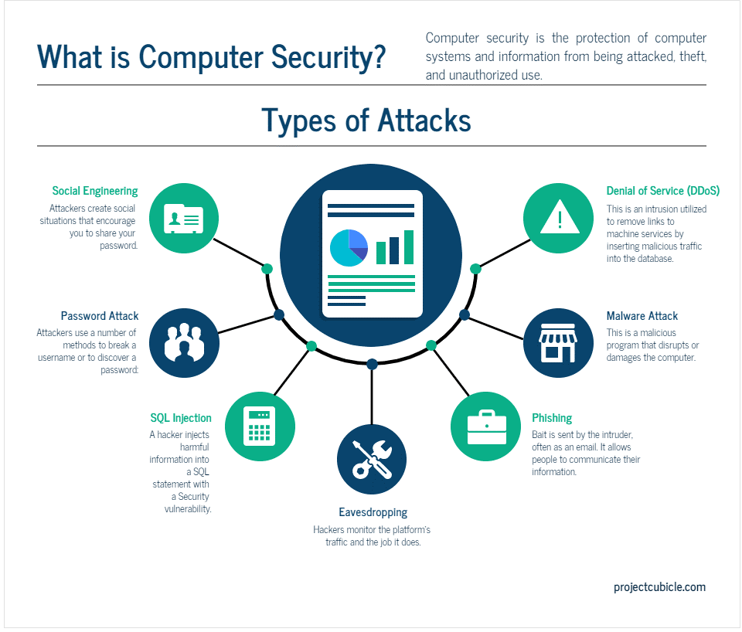

massively expanded the attack reach of hackers.

Advancements of Attacks: Cyber attackers with advanced tools of today such as AI and machine learning are now capable to design increasingly more sophisticated attacks which can easily be automated.

The Lack of Cybersecurity Experts: The advancement comes along with a lack of cybersecurity professionals worldwide, who constitute large reliance on automated systems and AI solutions.

Challenges in Threat Detection and Mitigation

Some of the major concerns in the threat detection and mitigation in cyber attacks are;

Volume of Alerts: Traditional security systems produce too many alerts that overwhelm security teams.

Zero-Day Vulnerabilities: New vulnerabilities that hackers use before a patch is developed.

Evolving Threats: Attackers keep on evolving in an effort to avoid security mechanisms thus making it difficult to be one step ahead of the attack.

# 1.2 Role of Threat Intelligence in Cybersecurity

What are Cyber Threat Intelligence?

Cyber Threat Intelligence (CTI) is the actionable information available to an organization about threats to its systems or data. CTI typically includes information regarding the tactics, techniques, and procedures (TTPs) of attackers which enable organizations to anticipate potential attacks and proactively defend against them. Indicators of Compromise (IoCs) are data points reflecting malicious IP addresses, domains, or file hashes indicating a violation.

Actors: Who is conducting the cyberattacks, their goals, and their preferred methods.

Vulnerabilities: Known weaknesses in systems or applications to which they succumbed.

#### Why CTI is Essential in Current Security Operations

The following are why CTI is part of modern security operations. They include:

Proactive Defense: With the use of CTI, organizations are able to prevent attacks before they can occur, rather than just responding to the occurrence of the incident.

Decision Making with Accurate Intelligence: Correct intelligence enables an organization to determine what resources to share according to the severity of the threats.

Collaborative Defense: The sharing of CTI across organizations, sectors, and even countries assists in building a unified defense system against cybercrooks.

#### Traditional Approaches to CTI

Traditional CTI employs the following: manual analysis, rule-based systems, and threat feeds. These are normally categorized into the following groups:

Signature-Based Detection: This involves the use of predefined patterns to identify known malware or exploits. It isn't helpful with regard to new, unknown threats.

These heuristic-based systems scan the behavior of files or applications and identify possible threats. However, they produce many false positives and are less flexible in nature.

However, with such growing complexity in threats, the transition needed was from traditional approaches towards such more automated, intelligent systems like deep learning-based systems.

# Chapter 2: Deep Learning in Cyber Security

# 2.1 What is Deep Learning?

## What is Deep Learning?

Deep learning is a subcategory of machine learning that exploits the ability of neural networks, many layers of which are used to automatically learn from vast amounts of data. Deep learning models can differentiate patterns and make predictions regarding anomalies without being programmed for each task. They can run with unstructured information such as images, text, or network traffic, which makes them very suitable to use in cybersecurity applications.

## 

## Evolution from Machine Learning to Deep Learning

In traditional machine learning, feature extraction was typically a process that needed domain expertise in pointing out features relevant to the problem from data. Deep learning, however, made this an automatic process through layers of interconnected neurons that learn hierarchical features from raw data. As time passed, it shows how deep learning has handled large and very complex datasets that apply to most cybersecurity scenarios.

## Why Deep Learning for Cybersecurity?

Deep learning, as a powerful tool for cybersecurity, is emerging due to the following reasons:

Scalability

Deep learning models can handle very large sized datasets, which are prevalent in modern security environments.

Automation

These models reduce dependence on manual feature extraction and rule-based systems, making for faster and more accurate detection of threats.

Adaptability: Deep learning models can learn and adapt to new, previously unseen threats (e.g., zero-day attacks) by recognizing patterns in large amounts of historical data.

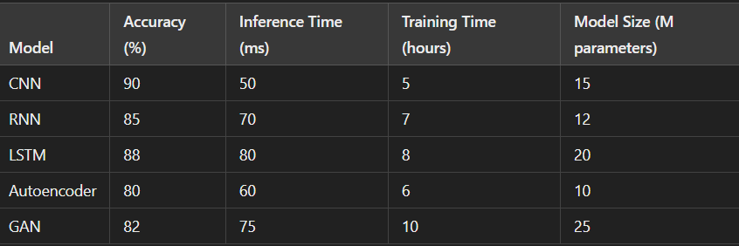

###### 2.2 Understanding Neural Networks

## Basic Architecture of Neural Networks

Neural networks are architectures made up of layers of nodes, or neurons. Every node performs a simple mathematical operation and passes the result on to the next layer. Commonly, the architecture will include:

Input Layer: Raw input data such as network traffic logs or malware samples.

Hidden Layers: These layers apply many mathematical transformations to the input data.

Output Layer: It makes the prediction that in the context of this tutorial is whether an event is benign or malicious.

##### Types of Neural Networks in Cybersecurity

Feedforward Neural Networks (FNN): Simple neural networks, where the data flows in one direction: from input to the output, which are mostly used in basic threat detection tasks.

CNNs-Structured data analysis for images or any structure that can be applied to malware detection by converting malware binaries into a graphical form.

RNNs-Sequential data processing, mainly in log files or time series. Therefore, this is best suited for the detection of patterns in network traffic.

Advanced Architectures-LSTM and GRU, as well as Transformers

Long Short-Term Memory (LSTM): RNN used for the purpose of capturing long-term dependencies and is very useful in those tasks where the context, in text or network flows, is of prime importance. The examples are phishing detection, etc.

Gated Recurrent Units (GRU): A simpler version of LSTM, which conducts with slightly decreased performance but fewer parameters.

Transformers. Transformer is a rising architecture deep in learning, with the capability of especially processing sequential data. They are largely efficient in their usage, especially in NLP for cybersecurity applications such as email phishing analysis.

Transfer Learning and Pre-trained Models

Transfer learning allows a deep learning model trained on one specific task to leverage it for another. Cybersecurity can essentially make use of enormous pre-trained models on threat detection tasks, thus sparing time and computational resources.

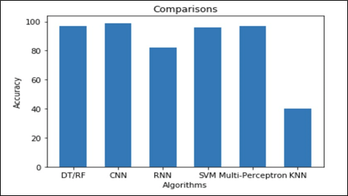

# 

# 

# Chapter 3: Four Deep Learning Methods for Cyber Threat Intelligence (CTI)

# 3.1 Intrusion Detection Systems (IDS) Using Deep Learning

## Definition and Types of IDS

An IDS is intended to analyze network traffic or system events in search for signs of intrusion and policy compliance. There are two main types of IDS:

Signature-Based IDS: Recognizes known attacks based on previous profiles or patterns otherwise known as signature-based system.

Anomaly-Based IDS: Reveals activities that are ‘abnormal’ within networks based on pre-normal established patterns, and can therefore detect previously unknown attacks or more specifically, zero-day threats.

This is a tutorial on Deep Learning for Anomaly Detection.

The traditional IDS techniques can be problematic since they are prone to false alarms, and incapable of identifying new or growing threats. Deep learning helps improve the IDS capabilities by enabling it use Machine Learning to classify network traffic anomalies thereby removing the necessity for rules. These systems are able to analyze behavior of the network traffic and, by identifying anomalies as malicious activities.

Key models include:

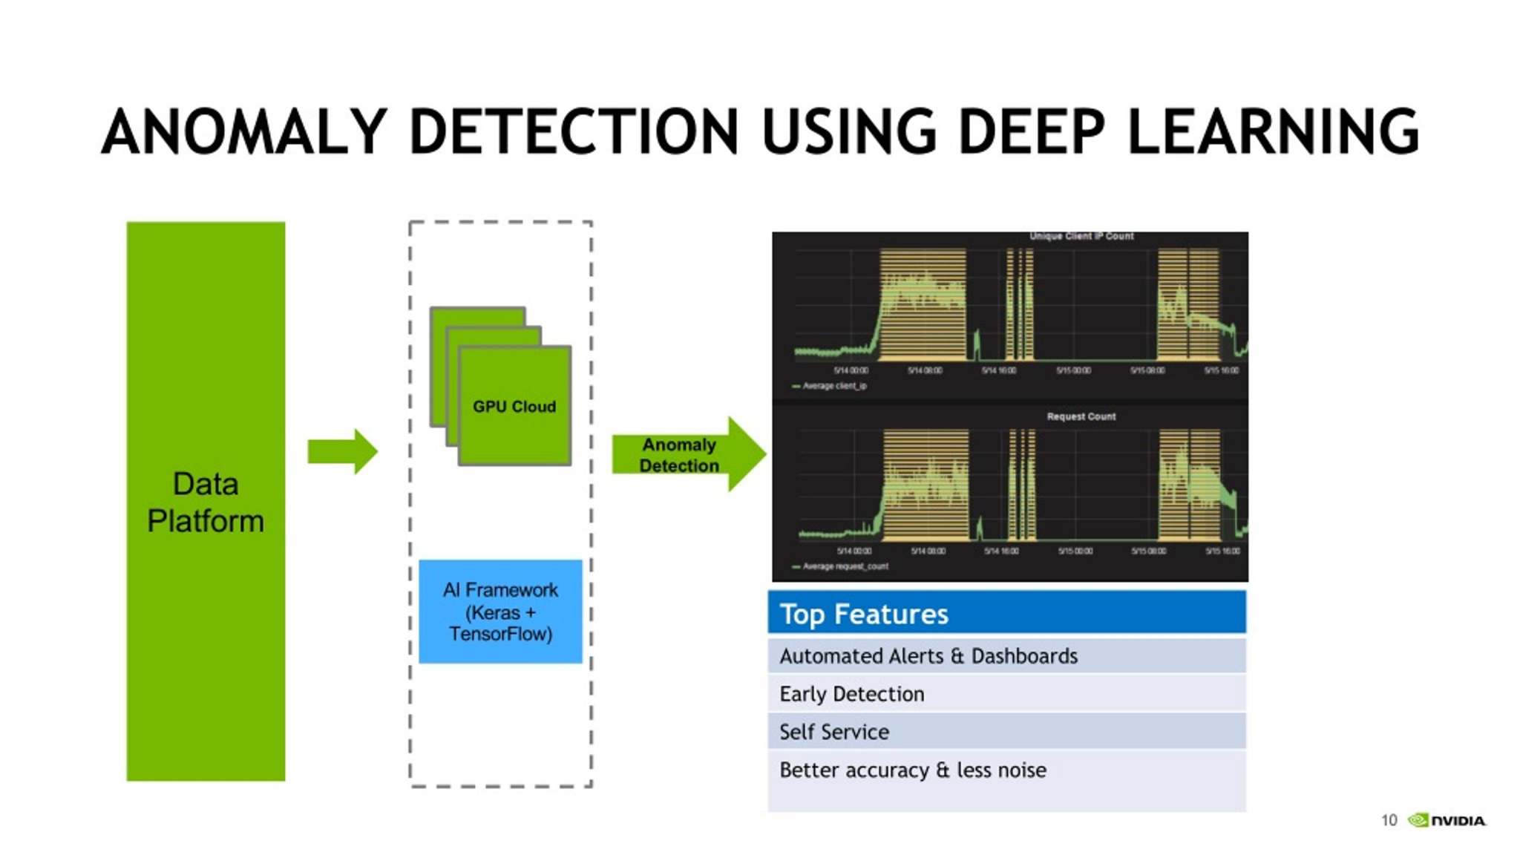

Autoencoders: These are the kinds of clustering systems made of unconstrained neural networks that remodel inputs into a format of lesser dimensions then try to recreate into its original format. Each time there is a difference between the input and the output signals an error. This makes them especially useful in intrusion detection when the aet is object and traffic is comparatively anamolous to normal network traffic.

Recurrent Neural Networks (RNNs): These are used to process log data of any type in order to recognize intruding sequential patterns, for instance, traffic flow in a computer network.

Example: Anomaly-based IDS using RNNs can track user instincts and alert if there are acute breaking intrusion assaults by drawing recognition to perplexing user log-ins.

## A Short Tutorial on Autoencoders for Feature Learning

Autoencoders can also be used to learn useful representations from the input data directly that in turn greatly enhances the accuracy of the intrusion detection. Under circumstances where the data forms a higher dimension such as network logs, abstraction features can be learned by deep learning and distinct attack patterns unnoticed earlier can be easily identified.

# 3.2 Malware Classification

The Function of CNNs and RNNs in the Classification of Malware

Malware detection is one of the crucial fields in CTI where pattern recognition methods usually proved to be inefficient at detecting new or more advanced types of malware. CNN has been effectively implemented in the classification of malware where the binaries are represented as images, with their code converted to grayscale for learning distinctive features.

## Static Malware Analysis: With CNNs, static analysis of malware, which involves study of a malware sample without executing it, can be done through analysis of code structures, byte sequences or by even transforming the code to images that can be fed to the CNNs.

Example: He also explained that a CNN-based malware detector which learns millions of malicious binaries just to identify the families of the malware, is capable of identifying new samples with visually similar appearances as the known samples.

## Dynamic Malware Analysis: RNNs are used in dynamic analysis where the behavior of the malware in question is observed during its executions; LSTMs are effective for this sort of analysis. LSTMs can learn the series of operations most malware engage in, including file reads or writes, network connectiveness, and memory change.

Static Analysis Methodologies, Dynamic analysis Methodologies

Static Analysis: CNNs are used mainly for categorisation of malware without executing the malicious code. Since this kind of detection occurs at a very higher speed, there is possibility to be left out of some advanced malware that tends to disguise its activities.

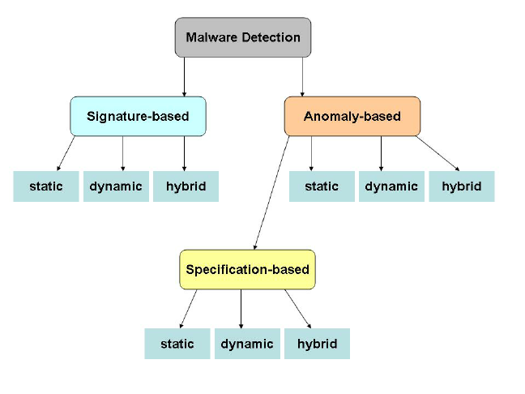

Dynamic Analysis: It is important to note that LSTMs and RNNs monitor the runtime behavior of a malware. Slightly more costly, this strategy works well when there is malware that may in its operation respond to certain stimuli within the system.

Case study on Malware detection systems

Several organizations have implemented deep learning-driven malware detection systems:

CNNs were employed by Microsoft to bolster the specifications of Windows Defender and specifically expand the ability of the program to detect malicious entities concealed within other legitimate software programs.

Google built a new system that has an RNN aimed at tracking down malicious apps that can be found on the Google Play Store, and determining apps that will engage in dubious actions over time, such as interacting with evil IP addresses.

# 3.3 Phishing Detection using Deep Learning

Autism Tools > Natural Language Processing For Phishing Emails

Phishing is perhaps the most prevalent and disastrous classes of cybercrimes. The analyzing of the textual data of emails can be performed by the use of NLP techniques enhanced by deep learning models such as Transformers and LSTMs. These models get to understand features such as language, structure as well as the intent of the messages with an aim of coming up with some kind of a pattern that may give a clue that this or that message is probably manipulative.

Example: The Transformer model in an email can identify comparatively small differences in, for instance, the content of phishing emails or, for example, small spelling mistakes, fake links, etc.

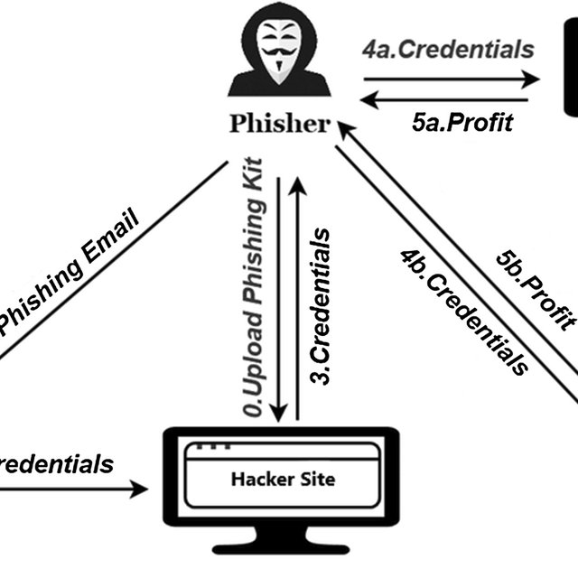

## Novelty of LSTM in the Analysis of Email and Web Page

Using a Long Short Term Memory (LSTM), one can model the characters or the words in an email or URL, and look for patterns that look sick. Ending with some form of identification, LSTM-based models can detect the structure of the URLs of phishing web sites that are crafted to resemble credible domain names.

This is specifically true in URL classification and the following section of this paper aims to establish this truth to the reader.

Deep learning models are also employed to decide between the legitimacy of a URL by training on a huge amount of legitimate and phishing URLs. These models can scan the character patterns, length and domain information on the fly and thus prevent any phishing attempt from reaching the users.

# 3.4 Deep Learning to Attack Hunting

## Cyber threat hunting: The application of reinforcement learning

Reinforcement learning (RL) has recently been utilized in threat hunting and involves an environment in which agents acquire the best course of action to take. In cybersecurity RL-based systems can self- navigate through each network and identify activity signatures that are suggestive of risks.

Example: A reinforcement learning agent could identify typical network traffic patterns and report encounters that may suggest lateral movement of an attacker.

KDD CUP 99: A standard benchmark established in 1998 for the creation of a labeled dataset for intrusion detection on many different forms of network assaults.

UNSW-NB15 Dataset: A recent dataset with fully realistic traffic for intrusion detection with ben and malicious traffic.

CSE-CIC-IDS2018: A combined raw data set that includes not only standard forms of intrusion but also contemporary threats such as DoS, FFP, and host breaking-ins.

Malware Samples for Deep Learning: There are some datasets such as VirusTotal, MalShare, and VirusShare, which consist of samples of malware stuff which can be used for static and dynamic analysis.

# 

# 

# 

# 

# 4.2 Data preprocessing

To train deep learning models on cyber threat data, several preprocessing techniques are required to make the data suitable for analysis:

Feature Extraction: For deep learning, feature extraction is generally done by an algorithm, although initial processing like, text parsing for phishing or transforming network data points for IDS is very important.

Data Labeling and Augmentation: Supervised learning algorithm require labeled data. Creating large sets involves data augmentation where for example network traffic is introduced with noise or the signature of malware is altered.

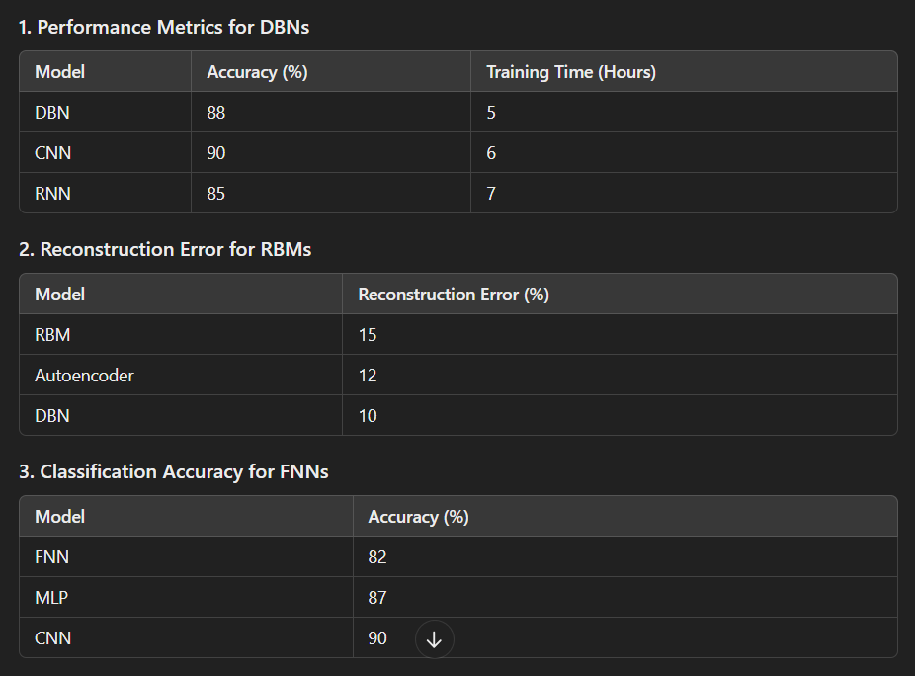

Handling Imbalanced Datasets: There is always a stark imbalance in cybersecurity datasets, where there are significantly fewer examples of attack than of normal use. Addressing class imbalance is made possible by using SMOTE (Synthetic Minority Over-sampling Technique) and cost sensitive learning.

# 4.3 Vozvyshennye modeli obucheniya i otsenki

Learning deep learning models in cybersecurity is a computationally expensive process and hence has to learn a set of hyperparameters to operate efficiently.

Cross-validation Techniques: To avoid such a problem, the k-fold cross-validation is normally applied while training the model.

Metrics for Model Evaluation: Some of the measurements that are normally used in management of cybersecurity are as follows;

Accuracy: The number of threats that were properly identified in relation to the total number of threats.

Precision: The capacity to properly identify the pertinent threats.

Recall: The capacity to identify all possible actual threat(s).

F1-Score: The level of precision and recall averaged that keeps both parameters at equal level.

Example: Even in IDS, if the accuracy is extremely high while the recalls are low, then the model will not be able to detect important intrusions, and therefore because of this, recall becomes a very important measure when evaluating cybersecurity models.

# Chapter 5: Real-time threat detection using Deep Learning in the application.

## 5.1 Real Time Traffic Monitoring

Real time threat detection works by filtering and analyzing live traffic in an organization’s networks to look for signs of threats while they are happening. This is because Recurrent Neural Network (RNNs) and Long Short-Term Memory (LSTM) networks, two deep learning models, are widely applied to process sequences of data and perceive temporal characteristics.

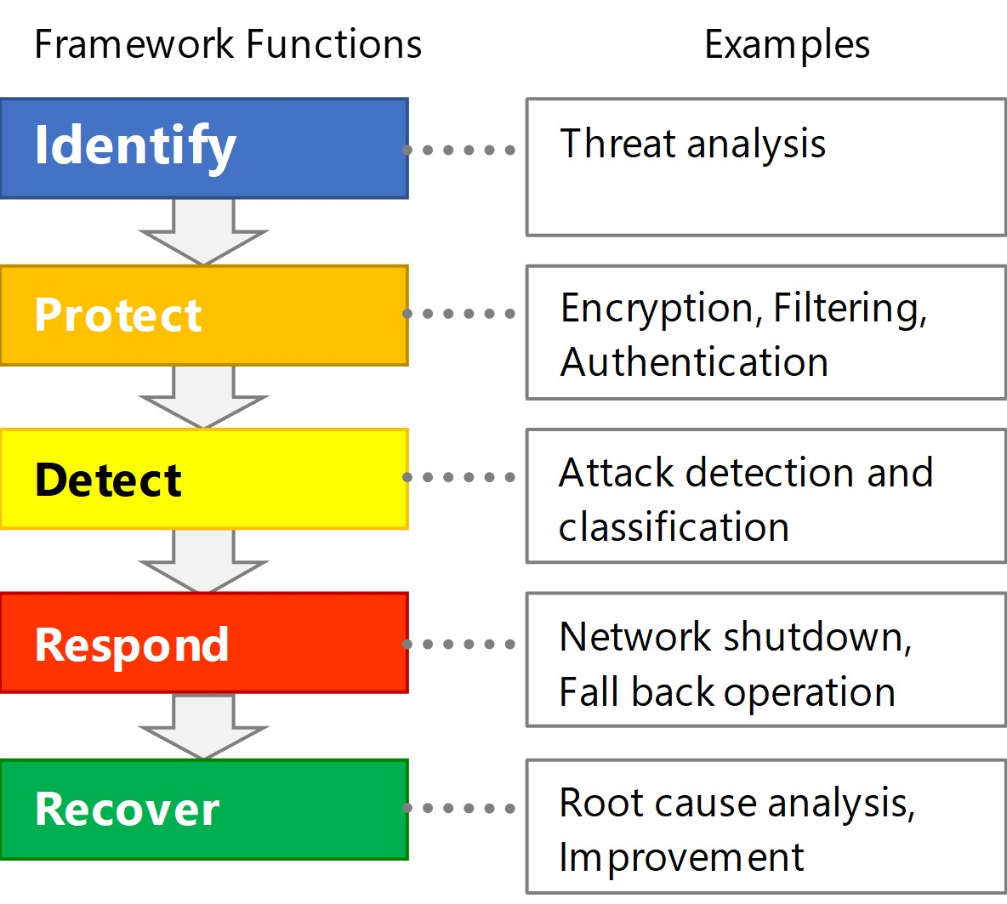

## Parameters of Real-Time Detection

Packet Inspection: Using deep learning, the fine feature of the incoming network packets is analyzed to determine odd packets. CNN can address the packet data in the same way as the matrices of the images to search for patterns reflecting a threat.

Flow-Based Detection: LSTMs examine sequences of network connections, for example, and isolate abnormalities in traffic patterns from normal traffic.

Findings from Applying Real-Time Detection Tools to Three Case Studies

Cisco’s Talos Threat Intelligence: Implemented in real time to detect network intrusions, malware and phishing attempts within millions of network events.

Zeek (formerly Bro): An Open source application developed to incorporate deep learning models to identify different traffic hazards in real time; including; port scans, DDOS, as well as exfiltration.

5.In Real-Time threat detection and response process, it holds the place of 2.

Techniques for threat detection in real-time make it possible to operate automated response mechanisms when needed to reduce losses. Deep learning models can automate the response to certain types of cyber threats, such as:

Isolating Infected Hosts: Use of deep learning in carrying out the detection of malware within a network may lead to an immediate response such as quarantining the device.

Blocking Malicious IP Addresses: When some traffic pattern from an IP address is identified as unwanted, the system can prevent further communications from the particular source instantly.

The current work explores the application of Reinforcement Learning for the development of autonomous response models.

Reinforcement Learning (RL) is specifically helpful to develop the real-time adaptive defense model. RL-based models can:

Adopt the best defense strategies depending on incidents feedback in the past.

Take automatic actions that employ responses for example changing firewall parameters or deploying traps to the attackers.

# 5.3 Deep Learning in Threat Intelligence Platforms (TIPs)

Threat Intelligence Platforms (TIPs) are platforms that aggregate data about threats making it possible to use the gathered knowledge for protection against cyber threats. Deep learning models embedded within TIPs enhance their ability to:

Correlate Data: Deep learning techniques can look for relationships between vastly dissimilar threat intelligence feeds (for instance, logs, malware, threat actor) for an even broader sense of threat examination.

Predict Future Threats: Security threat prediction can be calculated with the help of a model that may study historical threat data and extrapolate potential future threat attacks.

Example: Through using of deep learning models and its TIP, IBM’s QRadar comprehensively examines logs and multiple traffic data concerning complex multi-step cyberattacks in real time.

# Chapter 6: In this article, we discuss limitations and challenges in the cybersecurity field based on deep learning theories.

# 6.1 Data Protection and Liability Concern

Security deep learning models may need to get a hold of information peculiar to the security of a system, such as traffic logs, users’ behavior, and system activity. However, using this data raises significant privacy and ethical concerns:

Privacy Risks: Supervising Network Traffic and user activity for threat identification may be a violation of privacy in the event that data is not anonymized or/and secured adequately.

Ethical Use of AI in Security: There are some developmental applications of deep learning that could provide invasive monitoring: for example, the profiling of users based on the patterns of their activity – which would represent a clear violation of the right to privacy.

## Mitigating Privacy Risks

Federated Learning: In contrast with other forms of decentralization and distribution in which one keeps copies of data, federated learning enables organizations to train models on their data locally while transmitting only the learned parameters to a central model for fine-tuning, thereby increasing data confidentiality.

Differential Privacy: This is intended to prevent case of such data being taken from the trained models, in case the attackers get to work with the model itself.

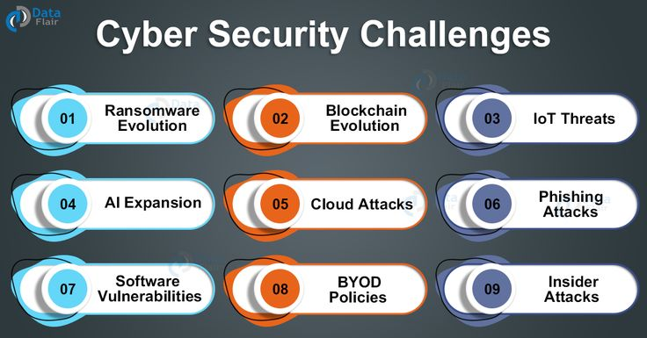

# 6.2 Adversarial Attacks designed for Deep Learning Models

Indeed, one of the serious limitations of deep learning models in cybersecurity is that the models can be easily deceived by the so-called adversarial attacks.

Types of Adversarial Attacks

Evasion Attacks: Adversaries change the inputs into a system (such as malware or network traffic) only slightly enough so as to avoid detection as the context is still executed.

Poisoning Attacks: Adversaries insert adversarial samples together with the correct labels into the training data set, and the model becomes trained to recognise such samples.

Mitigation Strategies

Adversarial Training: Known as the adversarial training which entails feeding the deep learning model with adversarial examples in a bid to enable it detect and withstand them.

Defensive Distillation: This technique diminishes dependence of deep learning models on small variation in the input data and hence narrows down the effect of adversarial attacks.

# 6.3 Internet Cost and Resource Needs

Jack-of-all trades that deep learning possesses comes with its expense: in terms of computational resources which includes GPUs, large data sets, and a lot of time required to identify what combination of hyperparameters works best.

Among the key challenges of management are market forces that keep on developing compounding the resource limitations problem.

Model Compression: Quantization and pruning are some of the approaches used to downsize the deep learning in a manner that we will have minimal to no effect on performance.

Transfer Learning: Other leverage models from different domains or related cybersecurity tasks can be further trained on comparatively smaller data sets and the learning process is less computational intensive than training from scratch.

# 6.4 Interpretable and Explorable Problems

The result being that when applying numerous layers and parameters deep learning models are highly difficult for the cybersecurity analyst to determine why a specific decision was made or prediction determined.

In dealing with the interpretability challenge, it is found that the following has been done:

LIME (Local Interpretable Model-agnostic Explanations): This technique offers local interpretation for individual predictions allowing analysts to appreciate why a particular model considered specific activity as suspicious.

SHAP (Shapley Additive Explanations): An approach with roots in game theory to interpret the output of every machine learning model and deriving feature importance for deep learning in cybersecurity.

# Chapter 7: Deep learning: key trends for the future of cyber threat intelligence

7.1. What is Explainable AI in Cybersecurity?

The goal of the Explainable AI or XAI is to establish ways that will provide more understanding of deep learning models. In the future, as cyber threat intelligence systems use increasingly deep learning, requirements for explainability counterparts will grow; for example, in the United States, the financial and healthcare sectors already demand detailed explanations.

The Steps to Enhance the Explanation in Cybersecurity

Model Agnostic Methods: The techniques like LIME or SHAP in the machine learning that allows to explain any given model.

Inherently Interpretable Models: And, incorporating simpler models such as decision trees together with deep learning for explaining to security analysts.



# 7.2 Federated Learning for Distributed Threat Intelligence

Federated learning makes it possible to train deep learning models locally across several edge devices or organisations without exchanging detailed information on the individuals. This trend particularly boost threat intelligence sharing between industries/nations for common goal.

Applications for FL in CTI

Cross-Industry Threat Sharing: It means that organisations can jointly train models for identifying new threats if they share no confidential information.

Decentralized IoT Security: Federated learning can facilitate the smart devices learning from the global cyberattacks, to improve their local detection of threats.

# 7.3 Coupling Quantum Computation with Deep Network

It is clear that quantum computing will revolutionise deep learning by solving problems that are currently intractable by classical computing architecture. In cybersecurity, quantum-enhanced models could:

Speed Up Threat Detection: Deep learning models for cyber threat detection maybe trained sooner when using quantum algorithms.

Break Cryptographic Algorithms: However, quantum computing is a threat on the same principle because it presents an opportunity to create new quantum safe algorithms in the future.

# 7.4 Autonomous Cyber Defense with AI

The cybersecurity in the future can be expected to include total self-organized defense solutions, which are operated solely by deep learning and reinforcement learning models and that are able to identify threats, as well as combat them.

SOCs:Security Operation Centers Advanced by Artificial Intelligence

AI-driven SOCs will increasingly automate routine cybersecurity tasks, such as:

This business breach consists of threat detection and response.

Documentation of events and events reporting.

Predictive defense based on actual realtime data analysis.

# 7.5 Human-AI Interaction of in Cyber Threat Intelligence

Despite the innovation brought about by AI in cybersecurity, humans are going to play an invaluable role. The trend toward Human-AI will be more concerned with utilizing the output of Artificial Intelligence as an enhancement to human analysts.

Purpose of Human Analysts in an AI World

Strategic Decision-Making: Even though operational processes can be assumed by the AI, human analysts will handle decision-making and intricacy or unpredictability.

Supervising AI Systems: There will be a demand for analysts who will monitor and optimise artificial intelligence systems, to guarantee productivity and conformity to ethical standards.

# Chapter 8: Conclusion

# 8.1 Summary of Key Insights

Cyber threat intelligence significantly improved its efficiencies owing to deep learning as it caused a significant advancement in detecting and responding rates and extent.

. Key benefits include:

Automation: Decreasing the ‘ ‘decision making ‘ ‘ load of human analysts on suspicion identification, malware categorization, and phishing identification.

Adaptability: Deep learning models’ ability to learn from the data makes them easily applicable when new threats are developed.

Predictive Power: By looking at previous events, deep learning can be used to forecast likely future cyberattacks and when threats are most probable.

# 8.2 Future Trends for Research and Development

Future research will likely focus on:

# Chapter 10: A Review onPhishing Detection using Deep Learning

# 

# #### 10.1: Phishing Attacks

Phishing includes a number of tricks to lure users into type-in errors which can be in form of emails, sites, or messages in an attempt to extort passwords, financial details and so on. These are rampant attacks which are many and not easily identifiable due to their dynamism.

# ##### Key Challenges in Phishing Detection:

- Content Evasion: Hackers amend content in order to slip past the regular filters.

- Sophisticated Attacks: The targeted threats such as the spear phishing and other targeted attacks are difficult to detect.

# #### 10.2 Deep Learning Models for Phishing Detection

The prevention of email phishing is more common through utilization of deep learning in email content and URL and metadata prediction.

## ##### Techniques Used:

- Natural Language Processing (NLP): For instance, the models include **BERT and transformers take an email or message and parse it to check how the content of the email matches the typical phishing language.

- Convolutional Neural Networks (CNNs): CNNs can be employed for URL classification by transforming the URLs as a sequence of characters or sequence of images, for detecting the phishing links.

- LSTMs and RNNs: A technique commonly employed to identify phishing activity and which primarily involves trying to identify sequences of action or words used in emails/messages behind a legitimate interaction/context sequence.

##### Example:

Google Safe Browsing is based on machine learning which identifies phishing URLs in real time to prevent users from visiting the malicious site.

# #### 10.3 Phishing Detection in Real Time

Real-time phishing detection can be used in the email client, browsers as well as in the cloud environment. Deep learning models can detect possible phishing emails or URL and alert users as soon as possible.

## ##### Example of Real-Time Deployment:

Office 365 Defender uses not only machine learning also deep learning to protect users from phishing, that utilizes content, metadata, and context.

# Chapter 12: Achieving a Superior Performance in the Insider Threat Problem Using Deep Learning



# #### 12.1 The Crisis of Inside Threats

Escalation risks are a special category that refers to people within an organization exploiting their privileges to obtain information or damage systems. While IT threats could be easily detected external threats from insiders are capable of accessing organizational systems and data legally and hence are not easily detected.

# #### 12.2 Deep Learning Techniques for Insider Threat identification

Using deep learning models, it is possible to track patterns of the user’s activities, which indicates various malicious insider actions.

##### Techniques Used:

- User and Entity Behavior Analytics (UEBA): The deep learning models can identify that the behavior is different from the normal pattern through logs, traffic analysis and usage patterns. **RNNs and Encoder- LSTMs are employed to forecast temporal sequences of actions and transfers from users for detecting deviant behavior.

- Autoencoders for Anomaly Detection: Autoencoders are able to learn what constitutes normal user behavior and therefore detect that which can be considered anomalous and potentially malicious.

##### Example:

Splunk’s UEBA employs ML as well as DL algorithms to identify malicious insiders based on changes in their behavior patterns in real-time.

# #### 12.3 Real Time Insider Threat Monitoring

Preventing insider threats before they cause a great deal of harm requires accurate, real-time detection systems. Artificial intelligence in the form of deep learning integrated into SIEM solves puzzles related to behaviors that deviate from typical usage.

# *Chapter 13: Deep Learning for Detecting Fraud in Financial Systems **

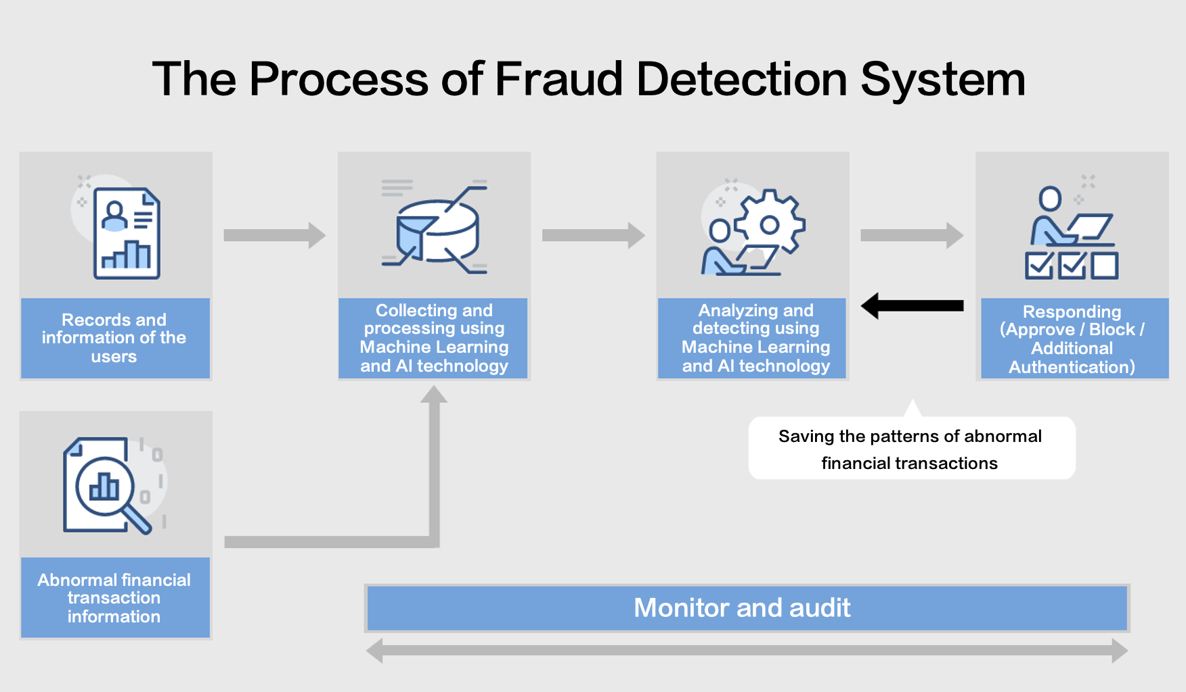

# ##### 13.1 Fraud Definition, Characteristics, and Its Relationship with Financial Systems

Some of the most prevalent risks that are affecting financial institutions include; fraudulent transactions, identity theft, credit card fraud amongst other related crimes. Indeed, traditional rule-based systems can often overlook such types of frauds or fail to identify them as attempts, in cases when they are very flexible and constantly changing.

# #### 13.2 Deep learning models for Fraud detection

Another application of deep learning is the ability to identify fraud in huge databases of actual and proposed financial transactions and identify patterns that can be associated with fraud.

## ##### Techniques Used:

- Graph Neural Networks (GNNs): Applied in situations, where, for instance, a large set of transactions is analyze for frauds which fraudsters try to mask behind complicated layers of fraud schemes.

- Recurrent Neural Networks (RNNs): Such models can be used to identify temporal fraud patterns regarding the sequential patterns of transactions over a period.

- Autoencoders: Since these models are commonly employed for unsupervised anomaly detection, they can learn the normal and fraudulent activity by describing the usual behavior of the customers.

##### Example:

PayPal, for example, deploys deep learning models to provide real-time decisions about the fraud examination of millions of transactions per second.

# 

# #### 13.3 Real Time Fraud Detection

Deep Learning integrated real time fraud detection systems can implement real time transaction blocking, auto alerting or additional authentication for high risk transactions.

##### Example:

MasterCard’s Decision Intelligence of the transaction gives an overall risk score based on Artificial Intelligence and deep learning techniques, the Decision Intelligence is capable of changing its behaviour in real time.

# Chapter 14: a case of Threat Hunting that uses deep learning*



# #### 14.1 What is Threat Hunting?

Threat hunting is different from threat intelligence, which is defined as the act of searching through network or data set looking for threats that cannot be detected by traditional methods. Unlike most cyber security solutions which are post-divulged threat methodologies, threat hunting focuses on attempts to proactively track down threats.

# #### 14.2 Deep learning-Driven Threat Hunting

Deep learning aids threat hunting because it allows analysts to sort through vast amounts of data looking for visible or latent threats.

##### Techniques Used:

- Reinforcement Learning (RL): RL algorithms can examine various constructs within a network all by their own to point out areas that may contain potential security threats.

- Anomaly Detection: There are specific patterns of suspicious behavior that can be detected in logs or traffic that are not seen by classical ML; these are known by deep learning models.

- Natural Language Processing (NLP): NLP models can be used, for example, to analyze large amounts of threat intelligence reports or logs, and to generate patterns that could be barely noticeable in the traditional informatics approaches.

##### Example:

Elastic Security’s SIEM includes deep learning models to help analysts in identifying threats using advanced hunting.

# #### 14.3 Automating Threat Hunting

Although it is still impossible to fully delegate threat hunting to deep learning, it can be considered a significant breakthrough in cybersecurity, as it can perform some amount of analysis on data that arrives in real-time and signal when more comprehensive analysis is required.

# 15.1 Unique Security challenges in IoT*

The IoT devices have a constraint in processing power, and they operate on minimalist OS systems which do not allow traditional security measures. As a result of the increasing number of connected devices, the risk of an attack surface has also risen as the attackers found various opportunities to penetrate the systems.

The IoT threat detection using deep learning has been discussed in this section as follows:

To enhance the deep learning models, current and potential threats facing IoT have to be identified, analyzed from network traffic, behavior of devices, and communications between devices.

# ##### Techniques Used:

- Federated Learning: This approach lets IoT devices work in parallel to come up with threat patterns while denying raw data to any of the devices reducing the risk of unauthorized use.

- CNNs and LSTMs: These models are to identify periods within which the behavior of IoT devices deviates, for example, a device behaving abnormally.

##### Example:

- Securing Smart Homes: Said deep learning models are now being applied to identify smart home device anomalies, like smart thermostats or cameras being accessed at odd hours.

# ##### 15.3 Challenges and Opportunities

The limited power of the gadgets used in IoT applications means that deep learning models used must be impactful and compact. Tremendous progress in edge computing and reductionism in deep learning models have opened up opportunities of deploying the models at the IoT devices.

---

These chapters present numerous emerging trends and issues related to the application of deep learning for C2 cyber threat intelligence, discussing many facets of cyberspace security and state-of-the-art approaches to threat identification and mitigation.Please let me know if you would like me to expand on any one type or additional chapters. run on lightweight operating systems, making traditional security solutions less effective. The

growing number of connected devices increases the attack surface, creating opportunities for cybercriminals to exploit vulnerabilities.

# #### 15.2 Deep Learning for IoT Threat Detection

Deep learning models can be adapted to detect IoT-specific threats by analyzing network traffic, device behavior, and communication patterns between devices.

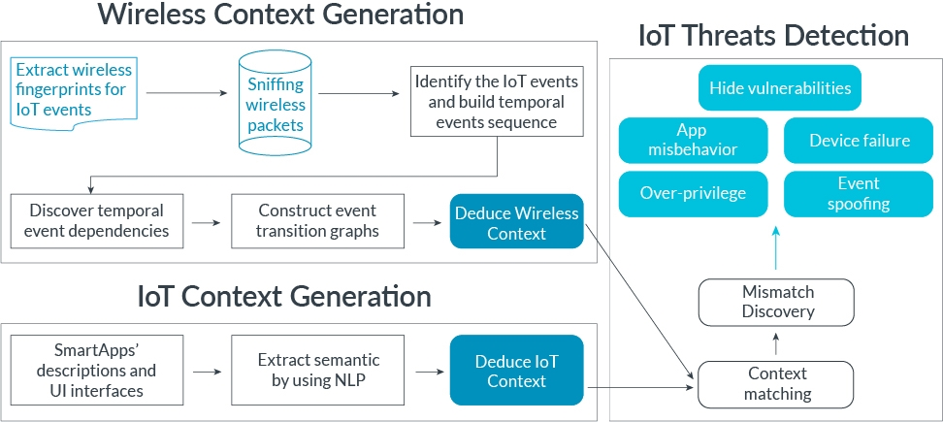

##### Techniques Used:

- Federated Learning: This approach enables IoT devices to collaboratively learn threat patterns without sharing raw data, preserving user privacy while improving security.

- CNNs and LSTMs: These models can analyze the behavior of IoT devices over time to detect anomalies, such as a device acting outside of its typical pattern.

##### Example:

- Securing Smart Homes: Deep learning models are being used to detect abnormal behaviors in smart home devices, such as thermostats or cameras being accessed at unusual times.

# #### 15.3 Challenges and Opportunities

The constrained resources of IoT devices mean that deep learning models need to be efficient, both in terms of processing power and memory usage. Advances in edge computing and model compression techniques are making it possible to deploy deep learning models directly on IoT devices.

---

# 

# These chapters cover a wide range of cutting-edge applications and challenges in using deep learning for cyber threat intelligence, addressing various aspects of cybersecurity and advanced techniques for threat detection and prevention. Let me know if you would like further expansion on any specific topic or additional chapters